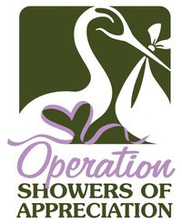
FOR IMMEDIATE RELEASE
Date: July 28, 2011

Media Inquiries: Jody Shervanick
Email: jodyshervanick@hotmail.com
Phone: 702.862.6064

What: Operation Showers of Appreciation

Who: Volunteers and Expecting Military Mothers will gather for the largest military baby shower in the state of Nevada on Saturday, July 30th at the Eastside Cannery Hotel & Casino. 125 mothers will be in attendance for this event.

Why: Many local military mothers are new to the area with no friends or family to provide them their own baby shower. In addition many have their husbands deployed in combat areas such as Iraq and Afghanistan. It’s important that our local military families know they are loved and appreciated.

When: Saturday, July 30, 2011 from 1pm-3pm

Where: Eastside Cannery Hotel & Casino-5255 Boulder Highway Las Vegas, NV 89122 (One Six Sky Lounge Room next to room reservations)

For more information, please contact Jody Shervanick PR Coordinator for Operation Showers of Appreciation. jodyshervanick@hotmail.com 702.862.6064

About Operation Showers of Appreciation: Operation Showers of Appreciation is a 501 c non-profit tax-exempt organization, whose mission is to honor our military families in a unique way by showering them with gifts for their newborn babies, providing support during difficult times, and letting them know the many sacrifices both the families and service members make are appreciated. For more information about Operation Showers of Appreciation, please visit www.osoamil.org.

